**[This Is What Really Hides In Taco Bell's "Beef"](http://gizmodo.com/5742413/this-is-what-really-hides-in-taco-bells-beef)**

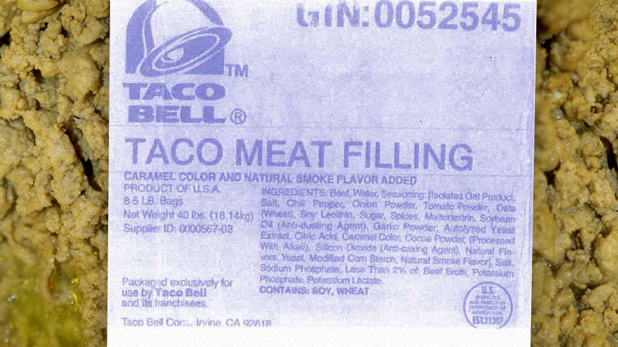

Published February 03, 2019 [Fox News](http://www.foxnews.com/)

Taco Bell "beef" *pseudo-Mexican delicacies* are really made of a gross mixture called "Taco Meat Filling" as shown on their big container's labels, like the one pictured here. The list of ingredients is gruesome. *Updated*.

Beef, water, isolated oat product, salt, chili pepper, onion powder, tomato powder, oats (wheat), soy lecithin, sugar, spices, maltodextrin (a polysaccharide that is absorbed as glucose), soybean oil (anti-dusting agent), garlic powder, autolyzed yeast extract, citric acid, caramel color, cocoa powder, silicon dioxide (anti-caking agent), natural flavors, yeast, modified corn starch, natural smoke flavor, salt, sodium phosphate, less than 2% of beef broth, potassium phosphate, and potassium lactate.

It looks bad but passable... until you learn that—according to the Alabama law firm suing Taco Bell—only *36%* of that is beef. *Thirty-six percent*. The other 64% is mostly tasteless fibers, various industrial additives and some flavoring and coloring. Everything is processed into a mass that actually looks like beef, and packed into big containers labeled as "taco meat filling." These containers get shipped to Taco Bell's outlets and cooked into something that looks like beef, is called beef and is advertised as beef by the fast food chain.

Can you call beef something that looks like ground beef but it's 64% lots-of-other-stuff? Taco Bell thinks they can.

That's the reason why an Alabama law firm is presenting a class action lawsuit for false advertising—[they are *not* asking for any money](http://www.latimes.com/news/nationworld/nation/wire/fl-taco-bell-suit-20110124,0,3088351.story)—saying that the fake Mexican food maker should label their processed clustermass of disgust as what it really is in all promotional materials, following USDA laws. It appears that they have a very good point.

According to the USDA, Taco Bell can't call this mixture "beef" at all. Beef is officially defined as "flesh of cattle", and ground beef is defined as:

Chopped fresh and/or frozen beef with or without seasoning and without the addition of beef fat as such, shall not contain more than 30 percent fat, and shall not contain added water, phosphates, binders, or extenders.

That is certainly nothing like the mix that they are using in their products.

The law firm argues that the meatmud correctly labeled as "taco meat filling" in the industrial packaging should be labeled in exactly the same way in all advertising and packaging, as the USDA mandates. Of course, the *All-New Double Decker with Two Times More Taco Meat Filling* would not sound very good on TV.

**The right to know**

Taco Bell's meat filling looks like ground beef before and after cooking, but it has been augmented with fibers and other substances to keep the price low. That's how they can offer tacos for 99 cents—and that's fine: There's absolutely *nothing* wrong with their processed mixture apart from being gross.

The problem here is that the consumers may believe that this "meat filling" *is* actually beef while it's not. If it looks like beef, it's labeled as beef, and it's advertised as beef, then it must be beef—except that substance is *not* beef. It's just "meat filling". That could deceive the public, which is why there is a class action lawsuit in the works. Consumers have the right to easily learn what they are eating before making a decision to eat a taco or not, just like they need to know before buying cloned meat or genetically modified vegetables or products containing corn syrup.

The final irony: The USDA says that any food labeled as "meat taco filling" should at least have 40% fresh meat. According to the Alabama law firm, Taco Bell stuff only has *36% meat.* Perhaps they should call it Almost Taco Meat Filling.

Thank you, Corporate America, for [yet another episode](http://gizmodo.com/5654066/chicken-nuggets-are-made-from-this-pink-chicken-goop) of [food fun](http://gizmodo.com/5662271/watch-six-months-of-a-happy-meals-eternal-life). [[WTOL](http://www.wtol.com/Global/story.asp?S=13885025)]

**The full list of ingredients in “Taco Meat Filling” is below.**

|  |  |  |
| --- | --- | --- |
| 1. Water | 1. Soy lecithin | 1. Citric acid, caramel color |
| 1. Isolated oat product | 1. Sugar | 1. Cocoa powder |
| 1. Salt | 1. Spices | 1. Natural flavors |
| Chili pepper | Maltodextrin (a polysaccharide that is absorbed as glucose) | Silicon dioxide (anti-caking agent) |
| Onion powder | Soybean oil (anti-dusting agent) | Sodium phosphate |
| Tomato powder | Garlic powder | Less than 2% of beef broth |
| Oats (wheat) | Autolyzed yeast extract | Natural smoke flavor |
| Yeast | Modified corn starch | Salt |
| Potassium phosphate | Potassium lactate |  |